Overlaying Filters and Image Enhancement using Image Processing Techniques

Hashwanth S  
 *B.Tech CSE*  
*Vellore Institue of Technology* Chennai, India  
hashwanth.s2019@vitstudent.ac.in

Akash A  
*B.Tech CSE*  
*Vellore Institue of Technology*Chennai, India  
akash.a2019@vitstudent.ac.in

Mohana Ganesh  
*B.Tech CSE*  
*Vellore Institue of Technology*Chennai, India  
mohanaganeshk.2019@vitstudent.ac.in

***Abstract—Filters are a source of infinite fun and hilarity. These filters make individuals seem adorable on video and are visually appealing. According to a new survey, 90% of young women use filters. Millennials continue to be huge fans of Snapchat filters. In this project, we tend to develop a Real time face filter application which allows the user to apply various face filters over their face. Considering the pandemic fact, the project will also be holding an additional module where it will be exhibited as a platform for selling face masks online. The user can try the mask on using various mask filters in this augmented environment.***

***Keywords—face detection; face recognition; haar cascade classifier; security.***

# INTRODUCTION

The introduction of Augmented reality (AR) to smart phones brought a novel approach to entertainment. From playing games like Pokémon to making funny faces on Snapchat, AR has become a common occurrence. While this technology seems to be advanced enough to borrow from a science fiction, a fun creation, the Snapchat style filter in Python is incredibly straightforward. In this project, we will create a filter that puts sunglasses on the face.

This filter, like any AR, depends on two key steps. First, it must determine the location of the video frame in order to process the image. In this project, any algorithm we use should accurately identify the location of the eyes. Second, it must modify the inserted image to fit the entire video frame. In this case, the image is a pair of sunglasses that should be the size of a pair of eyes when they are named. While both of these challenges sound daunting, Python implementation on OpenCV makes it easy.

One of the methods that can be used is to find biometric faces. This process is also called facial recognition. Facial recognition was a key factor in achieving safety. As mentioned above, there are several types of algorithms that can be used to detect faces. Each of them has advantages and disadvantages. Several methods include templates, filter and neural network, such as research conducted by Thai Hoang Le. The drawback of this algorithm is that it is very expensive. Alternatively, this algorithm analyses image pixels based on color and light intensity. In the process of getting a face, getting those values, it takes a long time and sometimes it makes sense to reach. Considering that the acquisition of a human face has a wide and varied degree of pigmentation value, it causes the pixels to need to be re-scaled to the size and accuracy of the image. Therefore, in this project, a method of classifying the haar cascade is proposed. According to Snehal B. Jagtap, the algorithm from Viola and Jones, or the so-called haar cascade classifier is often used as a facial recognition because it has benefits, such as, being able to see any objects, including a person's face, quickly. This method does not process the image by looking at the RGB value in all pixels but processes the image based on features such as Haar.

# FACE DETECTION AND FACE RECOGNITION

1. *Definition*

Face detection is the first step in facial recognition and part of face recognition. Face detection is also a component of computer technology that determines the location and size of human faces in any digital images by ignoring other objects. Face recognition is a technology used since the 1960s. Used in security system, robotic and visual interface. Face recognition works by identifying people's faces based on digital photographs or a pre-trained framework that you embark on a face mask. The face website has worked before the equivalent of someone's face to be identified by a face already stored on the website. These methods are incorporated into biometric techniques. Those techniques were needed for a face recognition program. Face detection captures the object of a person face who has already been photographed by the camera and was followed by recognition of the base of the face in the captured face images. The next step is to identify the face, where facial matching is done. Determined whether it was appropriate for the saved website or not. If an item is already stored in a database, then the item is identified, but if it does not fit, the item could not be identified.

## Haar Cascade Classifier

The main basis for the discovery of a Haar classifier item features like Haar. These features, instead of using pixel density values, use comparative value conversion between adjacent rectangular pixel groups. Differential contrast between groups of pixels is used to determine the light associated with dark areas. Two or three adjoining groups with distinctly related differences form a characteristic similar to Haar. Haar features can be easily measured by increasing or decreasing the size of the pixel group being tested. This allows features to be used to find objects of different sizes

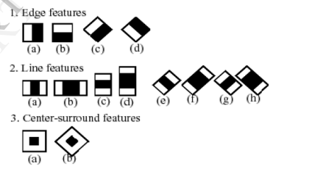

The presentation of the separators allows only small images that have a very high probability of being analysed in all aspects of the Haar that separates the object. It also allows one to change the accuracy of the separator. One can increase the level of false alarm and the level of positive pulse by reducing the number of stages. The opposite is also true. Viola and Jones were able to achieve a 95% accuracy of human face detection using only 200 simple features.

Determining a person's facial features, such as mouth, eyes, and nose, requires Haar classifier cascades to be trained first. To train dividers, this gentle AdaBoost algorithm and Haar feature algorithms should be used. Fortunately, Intel has developed an open library dedicated to reducing the implementation of computer-aided program called Open Computer Vision Library (OpenCV). The OpenCV library is designed to be used in conjunction with HCI field applications, robots, biometrics, image processing, and other areas where visualization is important and includes the use of Haar classifier acquisition and training. So, with the help of this algorithm system, we will see the human face in the video.

The human face finds Green Square as an indicator of the discovery process. As soon as the face is detected the user can stop the video and enter the victim's data such as person name, address, activity, criminal record if available. If the victim has a criminal record that can be described as a suspect. The checkbox option is provided in the system where the user can specify whether the person is suspected. This is the functionality of the first module in which a sample video is browsed and face detected.

## Feature Extraction

The main purpose of using features instead of pixels specifically is that features can work to integrate ad-hoc domain information, which is very difficult to learn using a limited amount of training data. In order to make the image geographical, one must first determine the area in which there may be facial features. The easiest way is to see the face in the photo first. The area containing the face will also have facial features. The best way to eliminate the detection of an extra feature is to geographically locate the facial features. It can be assumed that the eyes will be found near the head, the nose will be located in the middle the area and the mouth will be located close to the floor.

The upper 5/8 facial expressions are visualized for eyes. This area eliminates all other facial features while still allowing for a wide variation in the inclination angle. The facial area, 5/8 by 5/8 facial area, was used for nasal detection. This area eliminates everything except the upper lip and lower eyelid. The lower part of the face image was used to find the mouth. As the used face detector sometimes removes the lower lip the facial image was enlarged by eight to only the mouth.

There are two steps involved in removing the facial feature. Face detection is the first step in the detection of a face. This requires analysing the whole picture. The second step involves one face for each element. To extract the features, we used the Shi and Tomsi method. This method is based on the common assumption that light intensity does not change in image acquisition

## Face Regonition

Face recognition refers to the default or default process for matching face images. This type of technology forms a comprehensive collection of all face-to-face technologies that use different scanning techniques. All available face recognition techniques can be divided into four categories depending on their facial expressions:

1. A based look that uses complete texture features.
2. Model based on using face shape and texture, as well as 3D depth knowledge.
3. Template based on visualization.
4. Strategies using Neural Networks.

With the help of this process, the system can see face already found on video. Under the Face Name Frame Graph comparisons, known faces will do automatically find the name and everything else details. If the known face belongs to the suspect the face is then a square visual

symbol the box on the face gets a red color. Recognition the method is very important and complex. Seeing faces from real-time video it is very difficult and time-consuming process. The difference features in face detection can affect the amount of accuracy. The smaller value of confidence the better and more accurate the feature would be.

# PROPOSED WORK

This project explores the concept of real-time image manipulation. We have used OpenCV, haar cascade classifier, Image Sharpening, image brightness, and image denoising using FastNLdenoisingColoured.” haar cascade frontalface.xml” is utilized for this project, which is one of the OpenCV’s trained Haar Cascade models for real-time face identification. After detecting the facial region from the camera, it undergoes some preprocessing techniques such as grey scale conversion and normalization. In the final step the selected filters like sun glass, star glass etc. were placed over each individual’s face using the predicted points. Once the filter is applied and the video is ongoing, We will be capturing the image and undergo image processing techniques as mentioned earlier. For Image Sharpening Laplacian filter is used which is an edge detector used to compute the second derivatives of the image. So it determines if there is change in adjacent pixel values is from an edge or continuous progression. Laplacian filter kernels usually contain negative value in the cross, centered with the array. The corners can either be positive values or zero. It is particularly good at finding the fine details of the image. Also, we have slightly increased the brightness of the sharpened image for obtaining better quality, by adding a positive constant value to all the image pixel values which makes the image brighter. FastNL denoising is applied to remove the noise effectively while preserving the original image details as much as possible to get comparatively better output. Then the final processed image will be stored in a separate folder, will be useful for future purpose. The flowchart is given below.

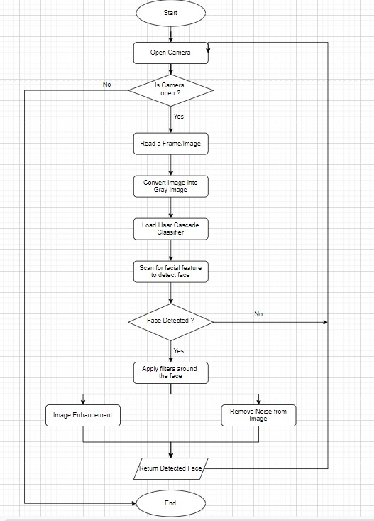

# IMPLEMENTATION

## Face Detection and Facial Key points Prediction

The first task is to detect the face and apply the overlay mask over the facial key points detected. We utilised "haarcascade frontalface.xml" for this project, which is one of OpenCV's trained Haar Cascade models for real-time face identification. After detecting the facial region from the camera, it was clipped to conduct pre-processing such as grayscale conversion, normalisation, and reshaping. The model used the prepared image as input and predicted the following face key points from the camera. The filters were then applied to each person's face using the estimated eye and brow locations as a final step. The width of the filter was established by utilising the top left and right eyebrow points, which were set somewhat above the brow points. Finally, the project's outcome is the mask overlay over the facial key points detected.

## Image Capturing

A simple way to record screenshots on your Windows machine is to use the PIL module that is already installed in many environments. PIL image grab is used to capture the window. The window which displays the filter being applied on the face is selected and then that window is passed to the PIL module in order to capture the image of that specific window.

## Image Processing

The image captured is then selected and then Laplacian filter is applied in order to sharpen the image. It makes edges appear more defined by darkening the darker pixels and brightening the brighter pixels. So this creates crisp edge between light and dark portions of the captured image which gives more contrast and clarity to the image. Then brightness of the processed image is increased a bit which makes darker areas lighter and light areas lighter too, so that the image look aesthetically appealing and gives it a professional look. Then the denoising on the processed image is performed using FastNLDenoisingColoured in order to reduce the noises associated with the image. This process is done in order to get the final image with less blur and less noise.

# NOVELTY

## Disadvantages of previous models

### Previous models fails to extend its application beyond 2 faces .The previously proposed works tend to apply a basic filter over the face but it limit itself to a certain number of faces.

### Sometimes the image will be blurred or more contrast in the case of previous works.

## How our project overcome?

### Our project overcomes the limitations and applies the filter over more number of individuals present in the frame. This expands the project’s scope.

### We have applied the image processing techniques to sharpen,brighten and denoise the image captured.

# CONCLUSION

Filers are playing a vital role in most of the millennial’s day to day life. As a matter of fact, more new filters or filter apps are increasing in the world of media. So, providing an amplified product is the goal of this whole project idea. For each detected face in the image or video frame, we will be extracting the facial landmarks for that face. Once we have the facial landmarks, we superpose the target filter on top of the desired region of the face. Our proposed solution uses Haar Cascade classifier. Haar-Features are good at detecting edges and lines and one of the plus side of haar classifier is that we don’t need to train Haar-Features, we can even create a classifier with a relatively small dataset.

##### Acknowledgment

 I Would like to express my deepest gratitude to my Teacher **Dr S** **Geetha Balan** for contributing their valuable time and efforts in helping me out with this project. Their suggestions and feedback have helped me a lot in improving the quality of the project. I would also like to thank my friends and family for their constant encouragement and support throughout the project. Lastly, I like to thank all my supporters who have motivated me to fulfil their project before the timeline.

##### References

1. R. Yustiawati et al., "Analyzing Of Different Features Using Haar Cascade Classifier," 2018 International Conference on Electrical Engineering and Computer Science (ICECOS), 2018.
2. Yang H, Wang XA. Cascade classifier for face detection. Journal of Algorithms & Computational Technology, September 2016.
3. Arnav Madan, “Face Recognition using Haar Cascade Classifier”, International Journal for Modern Trends in Science and Technology, Vol. 07, Issue 01, January 2021.
4. Singh, Vandna, Vinod Shokeen and Bhupendra Singh. “ Face detection by haar cascade classifier with simple and complex backgrounds images using opencv implementation. ”, 2013.
5. B. N. B J, U. G. S, N. A. V A and A. A, "A Novel Binarization Method to Remove Verdigris from Ancient Metal Image," 2021 5th International Conference on Intelligent Computing and Control Systems (ICICCS), 2021.
6. Alamgeer Ali, Kamal Kumar, Various Noises in Medical Images and De-noising Techniques, Proceedings of First International Conference on Computing, Communications, and Cyber-Security, 2020.
7. K H, M. A., B E, M., & A S, M. C., Python - Based Image Processing, International Journal of Scientific Research and Management, 2021.
8. Yurong Guan, Fei Zhou, Jing Zhou, Research and Practice of Image Processing Based on Python, [Journal of Physics](https://iopscience.iop.org/journal/1742-6596), 2019.
9. P. Viola and M. Jones, "Rapid object detection using a boosted cascade of simple features," Proceedings of the 2001 IEEE Computer Society Conference on Computer Vision and Pattern Recognition., 2001.
10. M. Khan, S. Chakraborty, R. Astya and S. Khepra, "Face Detection and Recognition Using OpenCV," 2019 International Conference on Computing, Communication, and Intelligent Systems (ICCCIS), 2019.